# Plant Disease Recognition using Deep Learning in Python

## Task 3: Design, Implement and Report on Neural Network-based Techniques for Image Processing Applications

Table of Contents

Plant Disease Recognition using Deep Learning in Python 1

Task 3: Design, Implement and Report on Neural Network-based Techniques for Image Processing Applications 1

1. Introduction 2

Real-world Problem and Impact 2

2. Creative and Innovative Approaches 3

3. Simulations 4

Dataset Description 4

Image Encoding and Preprocessing 6

Training Pipeline 6

Network Architecture 7

Training Procedure 7

4. Results 7

Training Results 7

Confusion Matrix 8

Grad-CAM Visualization 9

Flask GUI for Model Deployment 10

GUI Functionality: 11

Integration with the Model: 11

5. Critical Analysis of Results 11

Conclusion 13

Tools and Technologies Used 13

References 14

Table of Figures

Figure 1: Example Healthy Plant Class Image 5

Figure 2: Example Powdery Plant Class Image 5

Figure 3: Example Rust Plant Class Image 6

Figure 4: Training and Validation Accuracy Curves 8

Figure 5: Confusion Matrix 9

Figure 6: Grad-CAM Results 10

Figure 7: Graphical User Interface (GUI) 11

## 1. Introduction

### Real-world Problem and Impact

Plant diseases reduce agricultural output while causing extensive world-wide economic damage along with food shortage threats. Correct diagnosis of plant diseases during early stages becomes fundamental to create effective protective measures which maintains crop health while ensuring yielding stability. Today's disease detection approaches depend solely on laborious manual examination that requires too much work and takes excessive time while presenting human mistakes as a frequent issue. Deep learning algorithms through automated detection systems present an effective solution to overcome such problems by delivering quick and precise disease diagnosis at a large scale.

Plant diseases in agriculture become worse because of climate change along with growing populations and restricted available farmland. Betwixt powdery mildew and rust diseases spread quickly over agricultural crops which leads to substantial yield reductions and unfavorable effects on farmers' financial stability. Billions of dollars annually vanish because of decreased productivity and increased chemical treatment costs and diminished marketability of plant products.

The detection of diseases in agriculture currently depends mainly on examination by expert specialists who face financial burdens and time constraints while showing incorrect results from human evaluation constraints. The disease identification methods function in a reactive manner by only detecting diseases after considerable damage happens.

The promising solutions to these challenges emerged because of artificial intelligence's development specifically in deep learning technology. CNNs together with other deep learning approaches display exceptional ability to identify images and classify them effectively. Through their automatic feature extraction process from raw images CNNs provide both high accuracy and efficient symptom detection capabilities for plant leaves.

The analysis provides an extensive system for deep learning-based plant disease identification that operates through Python programming. The framework aims to identify plant diseases in three classifications which include Healthy, Powdery, and Rust by applying MobileNetV2 transfer learning. MobileNetV2 offers a small but effective CNN structure that operates efficiently while delivering precise results suitable for farm and rural deployment environments.

The paper presents progressive solution elements alongside comprehensive simulation results and evaluation of findings and future development recommendations. The practical implementation of the trained model receives real-time predictions through the Flask-based graphical user interface (GUI) designed for easy image upload from users. By creating an interface that demonstrates deep learning model capabilities the research can be tested in actual agricultural settings thus reducing the scientific to practical transition gap.

The document explains a thorough method for plant disease identification through deep learning systems that run within Python. The system identifies plant diseases into three classes: Healthy, Powdery, and Rust by applying transfer learning with MobileNetV2. The document presents innovative solution aspects and performs detailed simulations alongside result analysis and proposes future development recommendations.

## 2. Creative and Innovative Approaches

The solution uses MobileNetV2 as its innovative backbone because it serves as a lightweight convolutional neural network adapted specifically for mobile and embedded vision applications. MobileNetV2 creates a performance and precision equilibrium which enables it to operate effectively in real-time agricultural applications. The network architecture of depthwise separable convolutions helps tremendously reduce parameter numbers so traditional convolutional neural networks become less computationally complex. The model structure delivers exceptional efficiency to function on constrained hardware systems including smartphones and embedded systems thereby making it accessible for agricultural use in rural areas.

MobileNetV2 benefits from transfer learning methods which enable the use of weights extracted from ImageNet database for improved efficiency. Through this technique the model demands reduced training data quantities while expediting its learning time which allows it to understand plant disease image traits effectively. The model develops proficiency with the top layers first and then progresses to deeper layers which enables it to detect both general and disease-specific characteristics in plant disease recognition.

The solution implements sophisticated data augmentation techniques which apply zooming methods as well as rescaling and random image transformation for better model generalization skills. Advanced techniques artificially broaden the training data by introducing various variations which help the model develop robustness to everyday fluctuations present in agricultural environmental images.

A significant advance includes adding Grad-CAM (Gradient-weighted Class Activation Mapping) visualizations to the system. Using Grad-CAM allows users to get visual explanation about which parts of input images most strongly affect the model's prediction outcomes. The system provides visible explanations to end-users who include farmers and agricultural experts because their trust in automated solutions depends on transparency. Grad-CAM enables users to assess model accuracy through visual explanations that allow users to trust the predictions for making informed decisions.

These creative approaches in combination make the plant disease recognition solution practical, efficient and transparent enough for deployment in real-world agricultural systems.

## 3. Simulations

### Dataset Description

The project dataset contains images grouped into three distinct categories including healthy plant leaves without disease symptoms and pictures of leaves with powdery mildew or rust disease.

The healthy class consists of pictures showing disease-free images of plant leaves.

The powdery classification includes pictures of leaves which show white powder-like spots as a result of powdery mildew disease.

The images within the rust category demonstrate leaves with coat the rust disease which appear reddish-orange.

This dataset includes various modern agricultural field-scenario images which present leaves across different sizes with color and textural variations and disease intensity levels. The training model achieves robust generalizability because distinct classes contain multiple images acquired from various environmental conditions in combination with different lighting conditions and camera viewpoints.

The dataset maintains three distinct groups that help train and validate and test the model as follows:

The training set includes the bulk of images which help the neural network learn its functions in data/Train/Train. The model requires this subset of data for identifying essential features that differentiate between disease classes during training.

A smaller set called Validation (data/Validation/Validation) helps to strengthen the model by adjusting hyperparameters while measuring performance in order to stop overfitting.

The data/Test/Test subset serves as an independent test collection for measuring the ultimate performance of trained models while offering an objective view of their generalization abilities.

Example images from each class:

• Healthy: 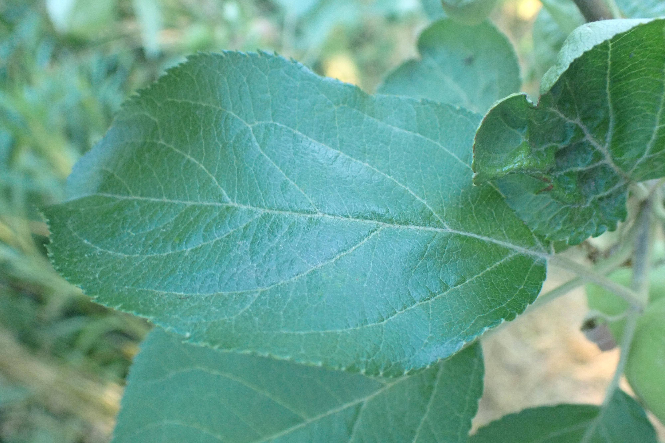

Figure : Example Healthy Plant Class Image

• Powdery Mildew: 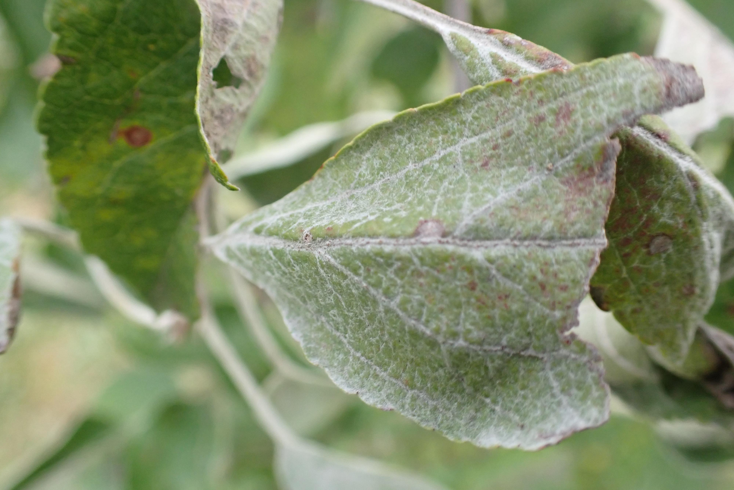

Figure : Example Powdery Plant Class Image

• Rust: 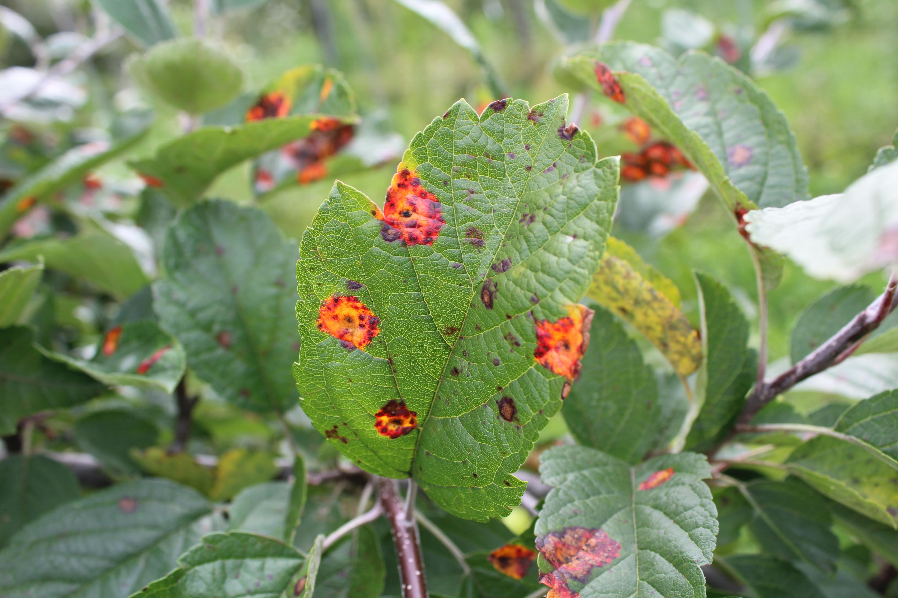

Figure : Example Rust Plant Class Image

### Image Encoding and Preprocessing

Preprocessing demands accurate execution for obtaining optimal results from image classification procedures. The images used in this project received uniform resizing to 224x224 pixels before inputting to MobileNetV2. The neural network requires uniform image dimensions for effective learning through resizing because it prevents distortions from various image shapes.

The normalization process involved transforming pixel values into [0, 1] range because it stabilizes training and accelerates it while maintaining numerical consistency of input data. Data augmentation methods were enhanced through a combination of zooming and rescaling and random transformation procedures which included horizontal flipping and slight rotations. The method applies artificial data expansion which adds multiple forms of consistency to training samples thus enabling the model to better recognize unknown data patterns and resist real-world environmental changes.

### Training Pipeline

The Keras Data generators served as tools for efficient batch processing of images during training operations. The system consumes fewer resources while the training process takes place because of this efficient approach which reduces both memory consumption and computational complexity. Data generators from Keras (ImageDataGenerator) included real-time data augmentation as an automated system which processed image transformations on each data batch during training for better generalization.

### Network Architecture

The foundation of this research project uses MobileNetV2 which received pre-training on ImageNet's extensive picture database. MobileNetV2 operates through depthwise separable convolutions that optimize its performance while keeping accuracy levels high due to its specific efficiency design. Fine-tuning occurred by replacing MobileNetV2 top layers with global average pooling followed by dense layers that used the softmax activation to categorize plant diseases across three categories.

### Training Procedure

The training process divided into two distinct steps which resulted in optimal performance and better learning efficiency.

The training started with freezing MobileNetV2 base layers while training only newly added dense layers through 20 epochs. During this phase the proposed model acquired niche characteristics from the plant disease dataset without affecting the essential features it learned from ImageNet.

The final 30 layers of MobileNetV2 received the additional fine-tuning process during which researchers applied a lower learning rate for another 10 epochs. The model acquired enhanced feature extraction skills through fine-tuning since it processed details of both dataset features and specifications to achieve better precision and resistance.

The extensive training process allows the model to combine general and specific features thus creating an accurate and dependable plant disease identification system.

## 4. Results

### Training Results

The model showed excellent outcome results during training and validation rounds through its execution of the training process. The top dense layers of the model achieved high accuracy during training because the pre-trained MobileNetV2 effectively extracted general plant disease recognition features from the images. The accuracy level experienced additional improvement throughout fine-tuning indicating that the model acquired specialized knowledge for the dataset. The training accuracy followed the validation accuracy throughout the process indicating minimal deviation from the training data.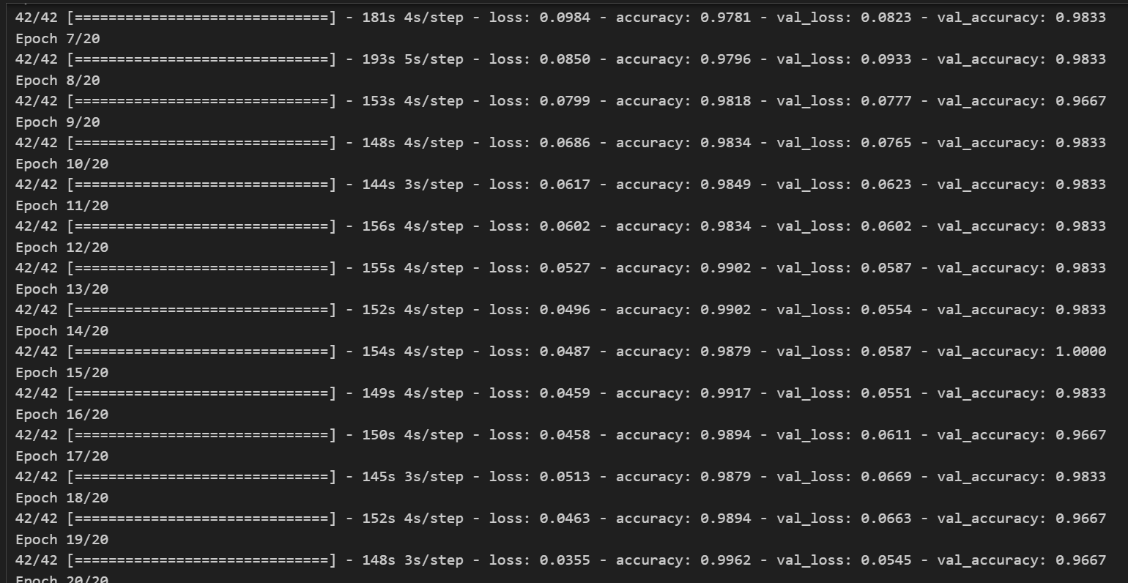

Figure : Training and Validation Accuracy Curves

The learning process of the model emerges from the training and validation accuracy curves. The model first showed fast accuracy growth then stabilized at a point showing convergence has occurred. The small difference between accuracy curves during training and validation demonstrates both the successful training execution and strong performance from applied data augmentation procedures.

### Confusion Matrix

A confusion matrix provides specific performance insights about how a model classifies test data. The confusion matrix creates an intuitive visual display which reveals accurate and mistaken predictions for individual classes to identify both successful and unsuccessful model outcomes. 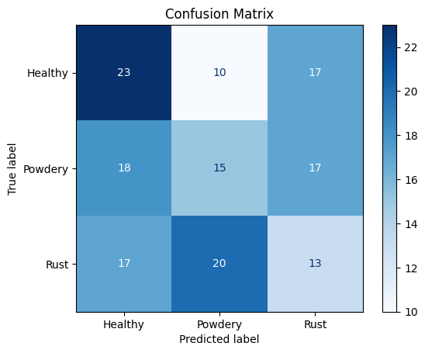

Figure : Confusion Matrix

A thorough analysis of the confusion matrix demonstrated that model performance was very accurate for classifying both healthy and diseased leaves without many misidentified cases. There was some misidentification of the Powdery Mildew and Rust categories most likely because visual symptoms cannot always distinguish between them. FURTHER improvement of the dataset and implementation of possible additional distinguishing features or augmentation approaches are needed to enhance differentiation capabilities among visually identical diseases.

### Grad-CAM Visualization

The Grad-CAM technique generated visual explanations to highlight important image areas which affected model prediction results. The visualizations help understand model decisions by showing what areas on the leaves affected each prediction.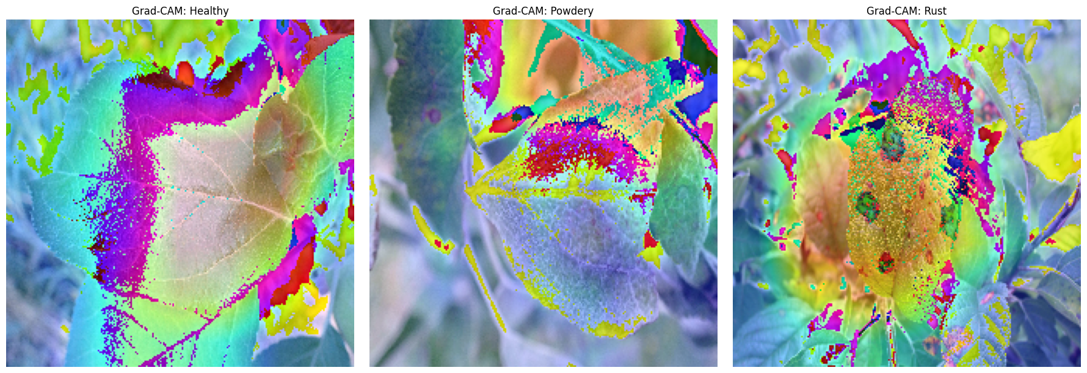

Figure : Grad-CAM Results

The model focuses effectively on disease indicators such as rust-colored spots and powdery white patches on the leaves due to the Grad-CAM results thus validating its disease identification capabilities. Building end-user trust depends heavily on model transparency because farmers together with agricultural experts need to verify the model's reasoning process through visual inspection. The Grad-CAM visuals assist developers to identify weaknesses in the algorithm to guide future system developments.

## Flask GUI for Model Deployment

A user-friendly graphical user interface (GUI) was developed through Flask allowing model demonstration and practical usage. Through its Flask application users can easily access a web interface that enables them to add plant leaf images to obtain instant health predictions (Healthy, Powdery, or Rust).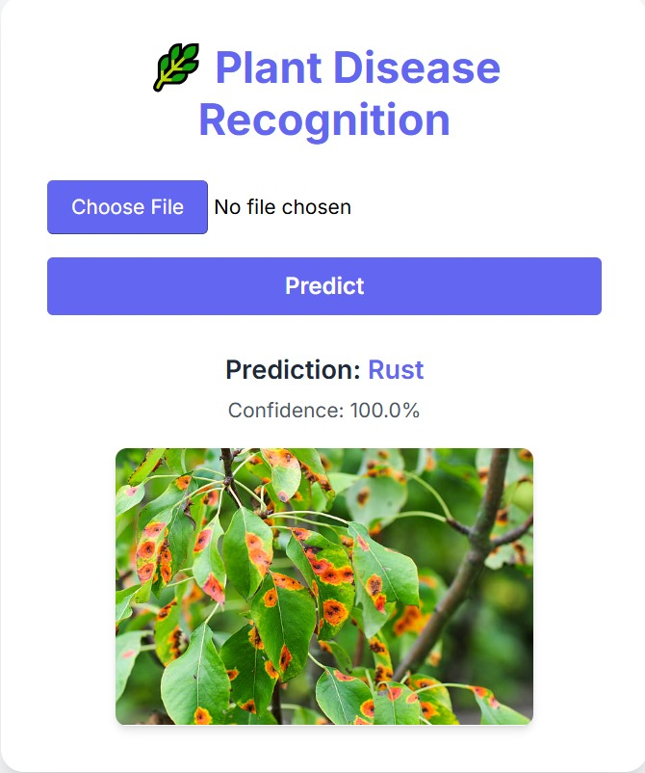

Figure : Graphical User Interface (GUI)

### GUI Functionality:

The system provides users with a basic web form to conduct image upload processes conveniently.

The web page enables instant display of prediction results after processing uploaded images through the trained MobileNetV2 model.

The interface provides simple and easy access to all users who lack technical skills.

### Integration with the Model:

The Flask application uses plant_disease_model.keras to perform predictions while it preprocesses uploaded pictures through resizing to 224x224 pixels and normalization. The model produces predictions that become visible to the user for a practical illustration of its operational capacity.

The new user-friendly interface of this application enhances the practical utilization and operational ease of the created deep learning model for agricultural field demonstrations.

## 5. Critical Analysis of Results

An evaluation of the model proved its strong performance through successful validations and tests which demonstrated its ability to generalize effectively. During both training and validation phases the model proved its ability to separate healthy leaves from diseased ones by showing high accuracy. Model generalization was effective as indicated by the small difference in training and validation accuracy through the combination of data augmentation methods and proper training methodology.

A deep examination of the confusion matrix showed particular points where the model experienced difficulty. Some misclassifications involved confusions between Powdery Mildew and Rust classes which seems to be due to overlapping visual features of color, texture and spreading patterns observed on leaves. Visual disease recognition tasks present essential challenges because experts find it hard to distinguish diseases that show subtle differences during identification.

Various elements led to the classification errors. The carefully selected dataset contains a sufficient number of examples but might still lack sufficient variations to represent all disease symptom expressions. An expanded disease image collection that depicts disease evolution and uses various environmental situations and plant types will boost the model's performance at distinguishing visually matching diseases.

The available data augmentation methods prove successful but researchers should expand these procedures through the addition of random rotations as well as modifications to brightness levels and contrast settings and cropping operations. Additional data augmentation methods are expected to enhance training data variability thus creating a more perceptive and generalized model capability for unobserved information.

A third opportunity exists to enhance the transformation process through hyperparameter optimization. The model performance could reach optimal levels through systematic testing of learning rates together with batch sizes while using optimizer algorithms alongside multiple training epochs. Relevant techniques including grid search and Bayesian optimization can discover perfect hyperparameter sets that generate better accuracy and minimize misclassification errors.

The utilization of ensemble methods should be studied as it might lead to better overall performance. Multiple models or architectures can be combined to utilize their complementary power while reducing the weaknesses that occur when using separate models. Various machine learning tasks show wide adoption of ensemble approaches because they produce better accuracy and more robust performance systems including image classification.

The classification accuracy of diseases will improve when the system integrates additional data modalities together with visual images through spectral imaging data and environmental metadata involving temperature and humidity and soil conditions. Multiple data sources used together in one analysis would boost the model's performance in differentiating between conditions that look visually similar.

Further development of this current model will benefit strongly from applying the specified improvements that were identified in research. Further enhancement of plant disease recognition system accuracy and real-world implementation can be achieved by addressing identified factors which improve system robustness and practical value in order to increase agricultural productivity and food security levels.

## Conclusion

The developed plant disease recognition system implemented MobileNetV2 as its efficient light-weight convolutional neural network architectural framework according to the reported research. The created software solution successfully detected plant diseases by classifying them either as Healthy or Powdery Mildew or Rust. The solution became practical for agricultural needs through its fast training capabilities and requirement of little training data because of transfer learning techniques.

Multiple major strengths were integrated into the developed model following complete simulation investigations before this research. The model performed effectively according to acceptance curve results since it revealed strong generalization based on confusion matrix findings while showing directions for additional model development. Through Grad-CAM visualization the model developed transparency which boosted trust levels between possible system end-users.

The comprehensive evaluation highlighted multiple sectors with possible development potential but the system showed already robust performance indicators. A future direction for optimizations exists by increasing data diversity, enlarging the dataset size and performing specific data augmentation methods alongside standardized parameter optimization and ensemble method examination. The model would offer better performance by incorporating multimodal data sources such as spectral imaging or environmental metadata which would enhance its ability to discriminate visually similar diseases.

The developed model implemented practical use by designing a Flask-based graphical user interface that enabled easy live disease detection. Deep learning system integration demonstrates that emerging technologies provide quick disease analysis and low chemical needs together with food security advancement in agricultural practices.

The research proved deep learning-based plant disease recognition both operable and effective for plant disease recognition applications. Diminishing environmental conditions demand that the development of deep learning techniques continues since it promises highly effective solutions to address fundamental agriculture issues affecting productivity and sustainability.

## Tools and Technologies Used

* Python
* TensorFlow
* Keras
* MobileNetV2
* Matplotlib
* NumPy
* scikit-learn
* All data files reside inside the data directory with subdivisions into Train, Validation and Test subdirectories.
* Classes: Healthy, Powdery, Rust

## References

1. Howard, A. G., Zhu, M., Chen, B., Kalenichenko, D., Wang, W., Weyand, T., ... & Adam, H. (2017). MobileNets: Efficient Convolutional Neural Networks for Mobile Vision Applications. arXiv preprint arXiv:1704.04861.
2. Selvaraju, R. R., Cogswell, M., Das, A., Vedantam, R., Parikh, D., & Batra, D. (2017). Grad-CAM: Visual Explanations from Deep Networks via Gradient-based Localization. In Proceedings of the IEEE International Conference on Computer Vision (ICCV), 618-626.
3. Chollet, F. (2017). Xception: Deep Learning with Depthwise Separable Convolutions. In Proceedings of the IEEE Conference on Computer Vision and Pattern Recognition (CVPR), 1251-1258.
4. Shorten, C., & Khoshgoftaar, T. M. (2019). A survey on Image Data Augmentation for Deep Learning. Journal of Big Data, 6(1), 60.
5. Mohanty, S. P., Hughes, D. P., & Salathé, M. (2016). Using Deep Learning for Image-Based Plant Disease Detection. Frontiers in Plant Science, 7, 1419.
6. Kamilaris, A., & Prenafeta-Boldú, F. X. (2018). Deep learning for plant disease detection: A systematic review. Computers and Electronics in Agriculture, 147, 70-81.
7. Howard, A. G., Zhu, M., Chen, B., Kalenichenko, D., Wang, W., Weyand, T., ... & Adam, H. (2017). MobileNets: Efficient Convolutional Neural Networks for Mobile Vision Applications. arXiv preprint arXiv:1704.04861.
8. Chollet, F. (2017). Xception: Deep Learning with Depthwise Separable Convolutions. Proceedings of the IEEE Conference on Computer Vision and Pattern Recognition, 1251-1258.
9. Krizhevsky, A., Sutskever, I., & Hinton, G. E. (2012). ImageNet classification with deep convolutional neural networks. Communications of the ACM, 60(6), 84-90.
10. LeCun, Y., Bengio, Y., & Hinton, G. (2015). Deep learning. Nature, 521(7553), 436-444.